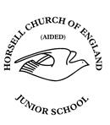
Horsell C of E (voluntary aided) Junior School

At Horsell C of E Junior School we believe we are all ‘made in the image of God’. Through a commitment to Christian values and high academic aspirations, we strive to provide a rich and inclusive education for every member of our school family.

TEACHING AND LEARNING POLICY
Date adopted: | February 2024
Author/ Owner: | Mrs Victoria Brinicombe (Deputy Headteacher)
Approved by: | Mrs Celia Wand (Headteacher)
Date reviewed: | January 2025
Date approved: | January 2025
Due for review: | June 2026

This policy has been equality impact assessed and we believe that it is in line with the Equality Act 2010 as it is fair, it does not prioritise or disadvantage any pupil and it helps to promote equality at this school.

“Intent”

Curriculum vision statement:
At Horsell CofE Junior School, we provide a ‘rich and inclusive education’. We believe that we all have unique, ‘God-given’ gifts that must be nurtured to their full potential in a broad and exciting curriculum.
Our learning is built around great literature, carefully chosen to reflect the rich diversity of faiths, beliefs and backgrounds of all members of our school family. Through our knowledge-rich curriculum, we aim to bring learning to life and inspire our children to become enquirers, risk-takers, collaborators, problem solvers and compassionate guardians of God’s precious world.
What does this look like in the classroom?
- School values (dignity, hope, justice, service, love and forgiveness) threaded through curriculum and planning choices
- Inspiring, diverse, challenging and enriching literature used as a stimulus for learning across the curriculum
- The use of quality resources to invoke awe, wonder, fun and enjoyment.
- Well-prepared, carefully considered lessons with strong subject knowledge at the forefront
- Frequent revisiting of previous learning to ensure all children know and remember more.

The Horsell Learner is:
A. Articulate
B. Brave
C. Collaborative

‘Implementation’
The key principles of teaching and learning are generic to all subjects of the curriculum. This policy therefore underpins every other curriculum policy.
Our approach to pedagogy is summarised below:
Teaching Model | Cognitive Model | Assessment Model
Rosenshine Principles of Instruction  See Appendix A | Bloom’s Taxonomy  See Appendix B | Assessment for  Learning  See Appendix C and D  are listed in Appendix

Our Teaching Model
At Horsell C of E Junior School, we believe that we are all ‘made in the image of God’. We want all members of our school family to fulfil their God-given potential.

At Horsell C of E Junior school we are committed to providing consistency of education across
every class in the school. We base our teaching practice on current educational research and
teachers are encouraged to critically engage with all aspects of their practice. Every subject has
key knowledge that children are expected to know, remember and understand and subject
specific skills are taught alongside this key knowledge. This is set out in the school’s knowledge organisers, which are used in the majority of subjects. Children are encouraged to make links
between the knowledge and skills that they have be taught in specific subjects across the
primary curriculum as a whole. High quality resources, and high expectations for all learners,
underpin this approach.

Rosenshine’s Principles of Instruction form the basis of the Horsell approach to teaching and
learning and provide teachers with a common language when planning, evaluating, and
discussing lessons. Teachers are expected to understand these principles and employ them
when teaching. These principles are not designed to be a ‘teach by number’ list, nor do they
provide a straightjacket for lessons. They are a core set of features which, with regular use, help
ensure ‘quality first teaching’ and learning cycles. These elements can occur at different points
in a lesson, or over a sequence of lessons, and can be integrated in different ways and at
different times. (Rosenshine and Stevens, 1986; Creemers & Kyriakides, 2008).

All Horsell lessons demonstrate main teaching inputs/modelling/instruction with key questions,
key vocabulary and carefully considered tasks/activities that match the children’s needs. Most
lessons will feature plenaries, reviews or reflection points identified through knowledge
organisers/quizzes. The key elements of a Horsell lesson are illustrated in the diagram overleaf:

Key Elements of a Horsell Lesson

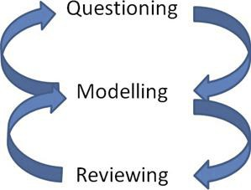

At Horsell Junior School we know that children are motivated to learn when they know the purpose of their learning.
At Horsell C of E Junior School, children know the audience and purpose of their work by focusing on WHAT they are learning, HOW they are learning it and WHY they are learning it.
All lessons include the following:
• a learning objective (What are we learning?)
• success criteria (How we are learning this?)
- relating learning to the wider curriculum (Why are we learning this)?

Key teaching expectations are set out a in short document, ‘The Horsell Way’ which is given to all teachers and attached as an appendix to this policy.

Our Cognitive Model

Bloom's taxonomy is a classification system used to define and distinguish different levels of
human cognition—i.e., thinking, learning, and understanding. It is a hierarchical system that
categorises the thinking skills of students, ranging from recalling information which is the most
basic skill to evaluation, which involves judging and stating an opinion about information.

Questioning Techniques
Questioning is one of the most important aspects of teaching and teachers at Horsell Junior
deploy a variety of questioning techniques. Questions should range from knowledge recall to
encouraging higher order thinking, and teachers use Bloom’s taxonomy when formulating
question stems. Questioning is always conducted in an atmosphere of mutual respect. The school operates a ‘no hands up’ policy to ensure maximum engagement from the class.

Our Values (golden thread)
Our Christian values of dignity hope, justice, love, forgiveness and service underpin all that we do and expect in our school community. At Horsell Junior school we recognise that learning about life’s bigger questions - giving children the opportunity to experience awe, wonder, delight and joy - is vital if our children are to, ‘experience life in all its fullness’. There are many opportunities to unpack these values in our curriculum subjects, beyond RE, PSHE, and daily Collective Worship.

Homework
At Horsell C of E Junior school we believe that homework is most effective when deployed to
consolidate and practise learning and skills taught in the classroom. New learning is best
introduced in the classroom, with the teacher, so that children are not overly-reliant on parental support to complete tasks set.
Our weekly homework provision consists of a written activity, reading activity, maths, spellings
and daily reading. Lower school (years 3&4) will be expected to read every night for at least 10 minutes. Upper school (years 5&6) are expected to read every night for at least 20 minutes. Reading records (HSO) should be kept up to date and signed by parents and monitored by class teachers. Where children are not completing homework, teachers will contact parents to discuss the school’s expectations. Children not completing homework will be asked to catch up. Homework is given out on a Monday and is to be completed by the following Monday. Homework is not set during the school holidays.

Our approach to homework follows our equality policy. Homework should always be accessible
for all children and where a child does not have computer/internet access, a paper based
alternative will be provided. Where a child may struggle to access the
learning, the parents should discuss this with the class teacher. It is then the
teacher’s responsibility to consider a more appropriate homework offer for the child.

‘Impact’

Teachers continually assess pupil progress through questioning and assessment for learning
during lessons and adapt their teaching accordingly. Small group teaching within the lesson is used to tackle misconceptions and move children’s learning on. Mini quizzing, and daily, weekly and
monthly reviews are also used by teachers to inform their teaching and plan the pupils’ next
steps. Every class also has a standalone 30-minute retrieval lesson once a week, which covers a range of curriculum subjects. This is to help embed learning into pupils’ long term memory.

The longer-term impact of teaching on the children’s learning is measured through subject
leadership, annual parent surveys, pupil conferencing, work scrutiny, internal and external
moderation meetings, termly data analysis and pupil progress meetings. The Governing Body examines the performance of pupil groups and monitors the delivery of the school’s curriculum. The school also benchmarks its performance against other schools.

The Governing Body, Headteacher and Deputy Headteacher and Inclusion AHT have a
responsibility to ensure this Teaching and Learning policy is evident in practice. Descriptions of
effective teaching and learning in this policy are used in the monitoring process through a
range of activities such as drop-ins, formal lesson observations, year group review mornings,
work scrutiny, planning scrutiny, analysing assessments through pupil progress meetings,
quality assurance within year groups, talking with children, parents and staff, and looking at the impact of feedback/marking.

Appendix A

Rosenshine’s Principles of Instruction

The Rosenshine Principles | What does it look like in the classroom?
Daily review | Learners ‘look back’ at the start of a lesson to put learning in context.
Present new material using small steps | Learners acquire new learning in small steps, carefully explained by the teacher
Ask questions | Teachers questioning is open and frequent, using Bloom’s Taxonomy as a framework, and deploying a wide variety of questioning techniques*
Provide models | Pupils should have a model and visuals in every lesson
Guide student practice | Lessons follow the ‘I do - We do - You do’ approach. Success criteria are used.
Check for student understanding | The teacher /Teaching assistant frequently assesses pupils’ understanding. (assessment for learning)
Obtain a high success rate | Teachers correct misunderstandings as quickly as possible and pitch the lessons correctly
Provide scaffolds for difficult tasks | Scaffolds are used and withdrawn when no longer needed. Careful consideration is given to those children with additional needs so that they can access the learning independently.
Independent practice | Pupils are given sufficient time to practise and embed key knowledge and skills.
Weekly and monthly review | Low stakes quizzes are used to embed knowledge and identify gaps. Knowledge organisers, which are also shared with parents, are used frequently so that children are clear on the key knowledge and skills that they need to learn for each subject. Quizzes should take place at weekly and monthly intervals for each subject, to ensure knowledge is embedded in pupils’ long-term memory.

*See Appendix C

Appendix B

Bloom’s Taxonony

Teachers use the vocabulary set out in the table below to ensure that there is a culture of high expectations in all lessons and learning tasks.

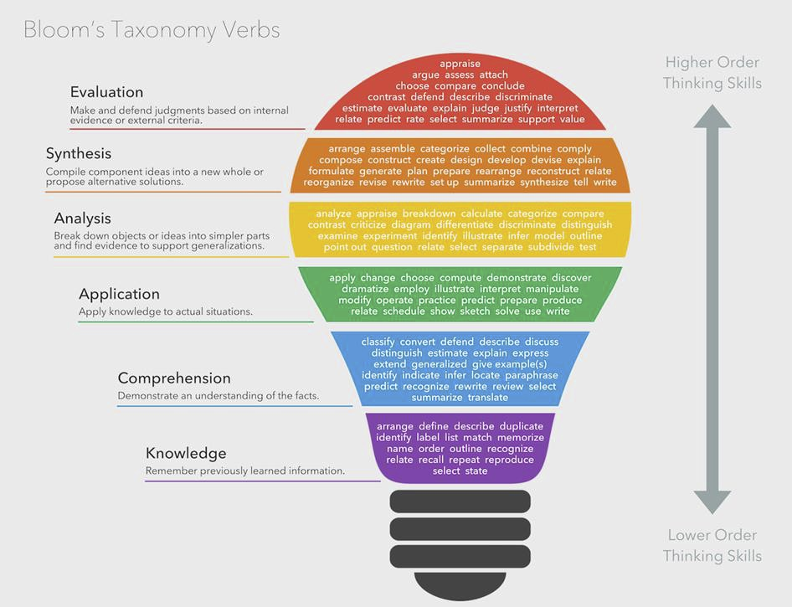

Appendix C

Questioning
Children sit with a talking partner and these are changed every week. Where this is not possible
this is in agreement with the Inclusion AHT. Children are encouraged to talk to their partner
when open questioning is being deployed and children are given the opportunity to formulate
their answers before a random pair (selected by a lolly stick) is selected to answer. Children
should be explicitly taught how to work with their talking partner at the start of every new
school year and teachers should continually model their expectations so that all children, and not
only the most articulate, engage with talk partner work. Talk partners should not be used when
the teacher is asking closed questions.
As much as possible, the school operates a ‘no hands up’ policy during class teaching time.
Questioning Techniques:
Cold Calling  Principle: All students should be involved in engaging with the teacher-student dialogue with time to think, and not be allowed to hide, dominate or be overlooked. | No hands up. Teacher asks questions and then selects children to respond based on their knowledge of the class, avoiding the pitfalls of hands-up or calling out. This should be the default mode for most questions.
No Opt-Out: (Based on Lemov, TLAC)  Principle: Students should feel safe in answering when unsure but, if they don’t know or get things wrong, they should be given the opportunity to gain confidence by consolidating correct or secure answers. Also, students should not be allowed to opt out by saying ‘I don’t know’. | If a child or several children get an answer completely or partially wrong or they say they don’t know, the teacher moves to other children or provides the correct answer. But the teacher then goes back to all those pupils who made errors or couldn’t answer giving them a chance to now say the right answer. This gives children an opportunity for practice but if done routinely, it also means that children soon learn there is no value if offering ‘I don’t know’ as a defence.
Probing:  Principle: In order to explore a child’s schema in any depth, teachers must ask them several questions; asking several children one question each provides shallow responses compared to when each child has to provided multiple responses. | In any given exchange, teachers are asking each child 3,4,5 questions before moving on, probing for understanding, checking for misconceptions, adding extra challenge, providing scaffolding to engineer success.
Say it again, better:  Principle: It is normal for first responses to be half-formed as children think aloud and formulate ideas. A second opportunity to respond allows them to finesse their answers, adding depth, accuracy and sophistication. It is important not to inhibit students when they are unsure; it’s also important not to allow them to assume mediocre answers are good enough. | When children offer a short, half-formed or partially incorrect answers, the teacher says, ‘thanks, that’s great͙. now say it again better. Try again but make sure you add in X and link it to idea Y’ giving the children an immediate opportunity to give an improved response.
Whole-Class Response:  Principle: This provides quick feedback to the teacher about the success of the relevant teaching and learning exchanges, identifies individuals who need further input and can help direct subsequent questions. | Using whiteboards, the teacher sets the  question, gives some response time and then, on cue ͙.’3,2,1 Show Me͙’children all show their answers at once. A simple A, B, C, D = 1,2,3,4 show of fingers also works very well for multiple-choice. The teacher then engages with the responses. and adjusts teaching accordingly, consolidating, re-explaining or moving on as appropriate.
Checking for Understanding:  Principle: Teachers should not assume that knowledge aired and shared in the public space of the classroom has been absorbed or learned, by any individual. It’s necessary to check for understanding from students to determine whether they understood what you meant. Do they now have the level of understanding you are aiming at? | After any question exchange with a particular child, the teacher asks a number of other children to relay back what they have understood. Even if they are answering a question that someone else has already answered, it is valuable for others to be given a chance to offer their version, showing what they have understood and, in so doing, giving the teacher feedback about how successful the teaching has been. It is especially powerful to ask multiple children, often yielding various different responses which throw up subtle points for further teaching.
Think, pair share  Principle: Children’s ideas may be incomplete. Having time to formulate an idea, and then share, can deepen understanding, maximise participation, and refine vocabulary | The teacher asks an open question. Children have time to formulate their own answer first, before working with a partner and then a larger group.
Word Wave  Principle:– This technique ensure high a high level of engagement across abilities. | The teachers ‘waves’ across the classroom so that all children have the opportunity to answer.
Round robin  Principle - Round robin can help students through: learning socially, drawing on each others’ knowledge, thinking more deeply, identifying misconceptions, participating equally and brainstorming quickly | Pupils sit in a circle, or round their desk, and take turns sharing ideas or answers to a question or problem. A ‘facilitator’ may record key points and insights.  Round robin can be verbal or a piece of paper can be passed around the group.
Choral call out  Principle: Embedding knowledge into long term memory is the aim of every learning opportunity. Choral response can help children to retain information and key facts. | The teacher asks a question and the children, as a class, give a choral response.
Wrong answer, right answer  Principle: By presenting incorrect information alongside the correct answers, pupils have to work hard to articulate what they know to be correct. | The children are given incorrect and correct answers and have to select the correct one.
Ask the teacher | Children write questions on whiteboards, related to the learning objective, to ask the teacher.
Do you agree?  Principle: With this approach, pupils have to work hard to articulate what they know to be correct. | Children are asked whether or not they agree with a fact or answer written on the board. The teacher can use their responses to highlight and correct common misconceptions.
Popcorn  Principle: The more children are engaged with a question, the more active learning is taking place for the duration of the lesson. | The teacher asks a question and the children call out an answer, trying not to speak over one another.
Exit ticket  Principle: In requesting pupils to share some key knowledge at the end of the lesson, the teacher is made aware of those pupils who might need further support the following day. | The children have to give an answer to a question before being allowed to leave the classroom

Appendix D
Marking and Assessment
The Deputy Headteacher is responsible for the assessment timetable. Heads of Year are responsible for ensuring assessments are completed on time.
Maths and Reading assessments take place during assessment weeks, and the results of these assessment are logged on Arbor. Writing is assessed through the marking of extended independent pieces, which takes place at the end of each writing unit. An overall grade is logged on Arbor during assessment weeks. Some pupils may need to sit an assessment paper out of their usual year group. This is approved by the Deputy Headteacher and Assistant Headteacher/SENCO. Any additional ‘access arrangements’ (such as additional time) MUST be approved by the SENCO.
For all other subjects (excluding RE and PSHE), the school records assessment data using the FFT website, and uses end of unit quizzes and teacher assessment to record pupil attainment and inform assessment decisions.
RE is assessed through end of unit quizzes, and teacher assessment, and assessment is recorded on an excel spreadsheet. In PSHE, pupils’ understanding is assessed through teacher observation, discussion, and the use of floor books.
Autumn |  | Spring |  | Summer
Phonics check (if below 32) |  | Phonics check (if below 32) |  | Phonics check (if below 32)
First 20% FFT (half-termly) |  | First 20% FFT (half-termly) |  | First 20% FFT (half-termly)
Book band (half-termly minimum) |  | Book band (half-termly minimum) |  | Book band (half-termly minimum)
National Curriculum spellings (termly) |  | National Curriculum spellings (termly) |  | National Curriculum spellings (termly)
Foundation subjects (half-termly) |  | Foundation subjects (half-termly) |  | Foundation subjects (half-termly)
Multiplication checker (half-termly) |  | Multiplication checker (half-termly) |  | Multiplication checker (half-termly)
NTS GAPS (termly)  3-5 |  | NTS GAPS (termly)  3-5 |  | NTS GAPS (termly)  3-5
NTS Reading (termly)  3-5 |  | NTS Reading (termly)  3-5 |  | NTS Reading (termly)  3-5
NTS Maths (termly)  3-5 |  | NTS Maths (termly)  3-5 |  | NTS Maths (termly)  3-5
SATs baseline (Y6) |  | SATs Spring (Y6) |  | SATs Summer 2025 (Y6)
SATs Autumn (Y6) |  | SATs Mocks (Y6) |  | White Rose Unit assessments
White Rose Unit assessments |  | White Rose Unit assessments
Y3 Baseline using Y2 papers

Marking and Assessment Expectations
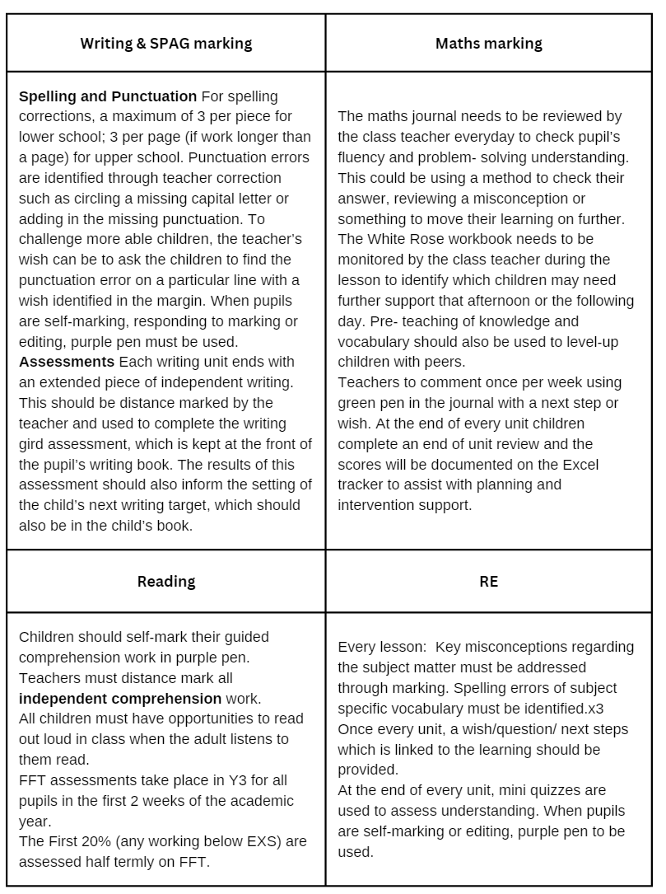

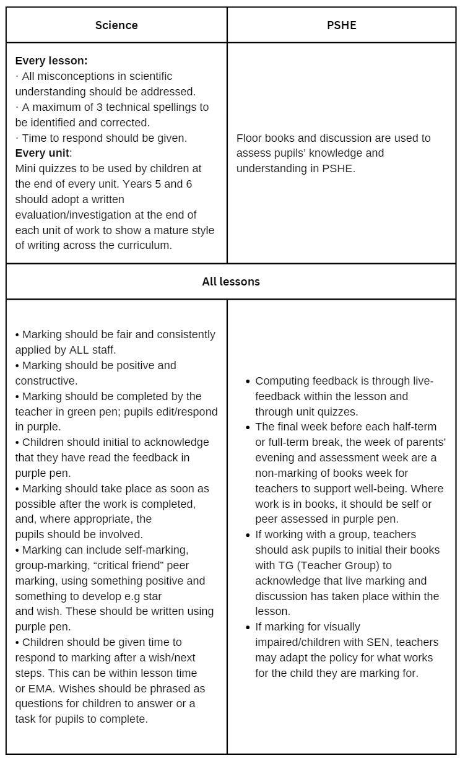
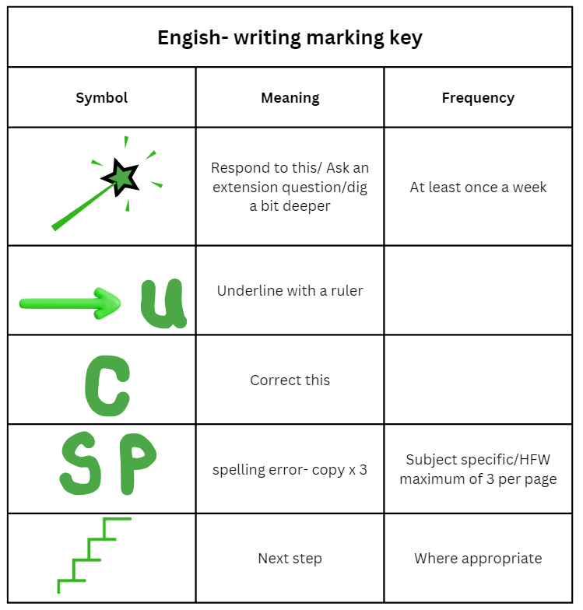

Appendix E
The Horsell Way


